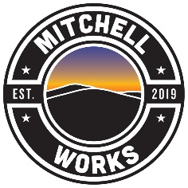

Partner Pledge Form
Mitchell Works educates young people and their parents about the job opportunities available in Mitchell County and the training required to pursue a career in those fields. The Mitchell Works program asks for your commitment to take an active and engaged role in the process. It provides an opportunity for your company to interact with students and parents while sharing information with the community about what you do and the jobs you offer. Mitchell Works Partners are listed on the MW website, are featured in videos and other promotional content and are given Mitchell Works materials to display. Establishing relationships with the school system, students and parents requires time but a little now can be a big investment in your future workforce.
Please select at least 6 of the options below. Return this form to pjensen@mitchellcountychamber.org.

□ Middle School Career Fair (Spring)
□ Middle School Tours (Fall)
□ 11th/12th grade Job Fair (Spring)
□ High School Class Tours
□ Mayland CC Adv Manufacturing Day
□ Job Shadowing
□ School speaking engagements
□ High School lunch meet & greet
□ Internship Program ($)
□ Mitchell Works advisory council
□ School Volunteer
□ Mitchell Works-Teacher/Counselor Internships ($)
□ Mentor Program
□ Mitchell Works Event Sponsorship ($)
□ Mitchell Works Investor ($)

As a Mitchell Works Partner I commit my time and resources and those of my employees to participate in the above activities. I also commit to completing the annual Mitchell Works survey and displaying Mitchell Works materials at our company to recognize our business as a Partner.

____________________________________ ________________________________
Name Company
____________________________________ ________________________________
Email Date

